OFFICE OF RISK MANAGEMENT

ANNUAL REPORT FY 2023



[UnivRiskMgmt@uillinois.edu](mailto:UnivRiskMgmt@uillinois.edu)

**OFFICE OF RISK MANAGEMENT**

**Office of Risk Management**

506 S. Wright Street, Suite 247

Urbana, IL, 61820

217-333-3113

**SERVICE BEYOND EXPECTATION**

Reported to the Board of Trustees

November 16, 2023

# CONTENTS

INTRODUCTION 4

MAJOR INSURANCE PROGRAMS 5

MEDICAL PROFESSIONAL & HOSPITAL

GENERAL LIABILITY 6-8

PUBLIC LIABILITY & BOARD LEGAL 9-10

WORKERS’ COMPENSATION 11-13

PROPERTY 14

EXCESS INSURANCE 15-16

GLOSSARY 17-18

# INTRODUCTION

We are pleased to present the University of Illinois System Office of Risk Management Annual Financial Report for the 2023 fiscal year. All data in the report is as of June 30, 2023, unless noted otherwise. This report supplements other periodic reports made to the Board.

The Office of Risk Management was established at the direction of the Board of Trustees in 1976 to administer the University of Illinois Liability Self-Insurance Plan (“Plan”). The Plan covers exposures for medical professional/hospital liability, public (general) liability, and board legal liability. Coverage under the Plan is subject to the terms and conditions as set out in the Plan document.

On June 30, 2023, the Office of Risk Management, including the Office of Claims Management/ Workers’ Compensation, (collectively called “RISK”) completed its 47th year administering the system’s insurance programs. Since its inception, RISK has endeavored to use effective risk financing techniques while continually improving the delivery of our services in support of the system’s mission. To accomplish these objectives, we consult on relevant insurance matters before and after a loss occurs to protect the system’s assets and operations. In addition, RISK has the responsibility of carrying out the policies of the University of Illinois in matters relating to risk financing and insurance, as well as administering the workers’ compensation self-insurance program. The RISK office is a department within the Office of Treasury Operations and reports to the CFO of the University System.

The University of Illinois faces many types of risk, such as bodily injury and property damage losses (public liability), charges of discrimination and wrongful termination (educators’ legal liability), on-the-job injuries (workers’ compensation), and adverse medical outcomes (medical professional liability). The RISK office provides advice to system leadership on the advantages and disadvantages of accepting, self-insuring, or transferring potential liabilities for the aforementioned risks. Managing operational risk is the responsibility of leadership at the universities and the UI Health enterprise.

### Duties assumed by RISK

* Purchasing and maintaining competitively priced commercial insurance policies to complement the self-insurance program. RISK manages approximately fifty policies.
* Analyzing risk transfer and financing methods and collecting exposure and claims data information.
* Issuing RFPs for commercial insurance products and consulting services.
* Allocating and collecting internal assessments for insurance and funding requirements.
* Issuing certificates of insurance and evidence of self-insurance coverage.
* Negotiating and settling property losses and processing legal expense payments.
* Preparing an annual report for the Board of Trustees and preparing documentation for auditors.
* Serving on university committees, in addition to participation with IPHEC, Big 10, and national insurance organizations.
* Advising units on cost containment and loss control programs to address adverse loss trends.
* Reviewing insurance requirements and subrogation language in contracts and leases.
* Advocating for transitional and return to work options for injured employees.
* Acting as a resource to the university community on issues such as auto liability, use of waivers, contractual risk transfer, and professional liability.

# MAJOR INSURANCE PROGRAMS AT-A- GLANCE

The self-insurance account funds have the following common elements: fund contributions, investment income, and insurance company recoveries (if any) less settlements, legal expenses, insurance company premiums, and administrative costs (Legal Counsel and RISK).

The summary below is a snapshot of the costs associated with the major programs discussed in this annual report.

|  |  |  |
| --- | --- | --- |
| **Program and Limits** | **Funding** | **Percent of overall program cost** |
| **Medical Professional**  $11M SIR* with a Buffer of $9m/$15m aggregate  $95M Excess Commercial Insurance | Total funding need increased roughly 12.5% or $3,030,520.  Total Funding: $27.1 million | 47.3% |
| **Public, Board Legal Liability**  Public Liability: $500K SIR  Board Legal: $1M SIR  $30M Excess Commercial Insurance | Total funding need decreased approximately 1.4% or $200,089.  Total Funding: $14.1 million | 24.6% |
| **Workers’ Compensation**  Statutory requirements fully self-insured  Employers’ Liability limit $1M | Total funding need decreased approximately 2.1% or $234,089.  Total Funding: $10.6 million | 18.4% |
| **Commercial Property**  $500K deductible  $1.5B commercial insurance per occurrence limit | Total funding need increased by 21.8% or roughly $998,283.  Total Funding: $5.6 million | 9.7% |

*Self-insured retention

**FY2023 Claim Settlement Summary**

On July 19, 2018, the Board of Trustees approved increasing the settlement authority delegated to the Comptroller from $250,000 to $1.0 million. The Comptroller is required to provide a periodic report to the Board on all settlements above $250,000 but at or below $1.0 million.

For the period 7/1/2022 through 6/30/2023, there were three settlements that fell within the range listed above. Overall, there were 119 total claims settled below $250,000 for a total of $3.4 million; and there were three claims that settled above $1.0 million for a total of $8.4 million.

# MEDICAL PROFESSIONAL AND HOSPITAL GENERAL LIABILITY

Medical professional liability insurance covers health professionals at the University of Illinois Hospital and Health Sciences System at Chicago, the various Colleges of Health Professions, and all student health service centers. The system has been self-insured for medical professional/hospital liability since August 1976 because commercial coverage for teaching hospitals was not available at cost-effective rates. Since March 1981, the system has purchased commercial excess liability insurance to provide additional coverage limits above a large, self-insured retention. The retention levels and the limits of coverage purchased have been influenced by availability in the insurance marketplace. $95 million of excess insurance was purchased during FY23.

The system annually obtains an actuarial analysis of this self-insurance program. The report estimates the ultimate cost of past losses and expenses (liabilities) on a discounted basis at various confidence levels. The system uses the 60th percentile confidence level to determine its outstanding liabilities. This implies there is a 60% chance that the reserves will be adequate and a 40% chance that the reserves will prove to be inadequate. FY2023 liabilities, when compared to Plan assets, show a funding surplus of $47.7 million. This surplus, amortized over five years, helps alleviate the funding need by $10.3 million. The actuarial firm also determines the amount needed to set aside for funding claims that occur during the new fiscal year. The combined total is the normal indicated funding contribution, which is roughly $22 million. Adding in the commercial excess insurance and administration costs brings the FY2023 total funding requirement to $27.1 million. This amount represents a 12.5% increase from the prior year’s requirement.

**Medical Professional Liability Self-Insurance Funding Projected at Beginning of Fiscal Year 2023**

Table showing Medical Professional Liability Self-Insurance Funding Projected At Beginning of FY23

# MEDICAL PROFESSIONAL AND HOSPITAL

## GENERAL LIABILITY, continued

As the graph below indicates, liabilities have remained remarkably consistent over the past ten years. Patient safety initiatives, aggressive litigation management, as well as success at trial have contributed to these positive results. For the period ending 6/30/2023, there was a 2.6 % increase in medical professional liabilities (discounted) from the prior year. Estimated liabilities at period ending 6/30/2023, were $202.3 million compared to $197.1 million at period ending 6/30/2022. For the period ending 6/30/2023, estimated liabilities compared to estimated assets resulted in a funding excess of $47.7 million.

From FY10 through FY19, the university’s retention was $10 million per occurrence with a $5 million per occurrence/aggregate buffer layer. In FY20, the retention was increased to $11 million per occurrence but the buffer remained at $5 million. In FY21, our retention remained at $11 million, but due to changes in the marketplace, we were forced to assume a higher buffer layer of $9 million per occurrence and $15 million aggregate.

For FY23, the self-insured retention is $11 million per occurrence with a buffer layer of $9 million per occurrence / $15 million aggregate. To use in a scenario, if our first claim was for $30 million, we would retain $20 million ($11 million retention plus $9 million per occurrence buffer). For our next claim, again using $30 million, we would retain $17 million ($11 million retention plus the $6 million remaining in the aggregate buffer). In the event of additional claims, we would retain $11 million for each and every claim, as the buffer layer had been eroded.

# MEDICAL PROFESSIONAL AND HOSPITAL

## GENERAL LIABILITY, continued

Beginning in 2010, the RISK office worked on a project designed to reduce the overall medical professional funding requirement. The focus was to limit the self-insurance fund’s exposure to loss when clinicians practice at off-site locations, meaning locations not owned or controlled by the system. In June 2011, the Board of Trustees approved off-site insurance limits of $1 million per occurrence and $3 million per policy year, bringing limits of liability for those practicing off-site in line with what medical practitioners would have in independent practice. The new off-site limits became effective January 1, 2012. Beginning January 1, 2014, the system purchased $15 million in shared commercial excess coverage to provide additional limits of protection for the COM-C physicians practicing off-site. This coverage protects against claims above the self-insurance fund limits of $1 million per occurrence and $3 million per policy year.

Large medical malpractice claims reserved at $500,000 or greater have been steadily increasing during the past five years as demonstrated graphically below. Postponement of trials due to the pandemic may have played a part in the increase.

**Claims Reserved at $500,000 or Greater**

Table representing Number of Reserved Claims at June 30 with different Values

# PUBLIC (GENERAL) LIABILITY AND BOARD LEGAL (DIRECTORS’ & OFFICERS’

**AND EMPLOYMENT PRACTICES) LIABILITY**

The Public Liability Self-Insurance program covers liability arising from system-owned or -controlled premises, as well as negligent acts of faculty and staff that result in property damage or bodily injury to a third party. In Illinois, a Tort Claims Act provides the means for citizens to recover damages from state agencies, and the Act requires claims made for certain torts be brought in the Illinois Court of Claims. In the Court of Claims, there are caps on damages of $2,000,000 per person. Actions brought in the Circuit and Federal court system are not within the purview of the Illinois Court of Claims.

The Board Legal Liability Self-Insurance program covers the system’s liability arising from alleged civil rights violations, discrimination, ADA violations, wrongful termination, and other claims that may be filed in the Federal or State Court systems. In addition, coverage extends to directors, officers, and employees who may be individually named in these claims.

Since 1990, both the public liability and board legal liability self-insurance programs have been supplemented by the purchase of commercial excess insurance above the system’s self-insured retention. The retention levels and the limits of coverage purchased have been influenced by availability in the insurance marketplace. During FY23, $30 million of excess insurance was purchased for board legal and $30 million for public liability claims.

The system annually obtains an actuarial analysis of its public liability and board legal liability self-insurance programs. The analysis estimates the ultimate outstanding losses and expenses (liabilities) on a discounted basis at various confidence levels. The system uses the 75th percentile confidence level to determine its outstanding liabilities. Funding for liabilities is adjusted to smooth contributions using a five-year amortization of fund surpluses or deficits. When compared to the Plan assets there is a funding deficit of approximately $20.4 million, representing a five-year amortized debit of $1,487,801. The actuarial firm also determines the amount needed to set aside for funding claims that occur during the new fiscal year. The combined total is the normal indicated funding contribution, which is roughly $9.3 million. With the cost of commercial excess insurance and administration added, the total FY2023 funding requirement is approximately $14.1 million. This amount represents a decrease of roughly $200,000 over the prior year.

The incidences of claims from employment practices have been increasing both nationally and locally. The system continues to focus greater attention on training and mediation to avoid expensive and protracted litigation.

# PUBLIC LIABILITY AND BOARD LIABILITY,

## continued

**Public and Board Legal Liability Self-Insurance Funding Projecting at the Beginning of Fiscal Year**

Table representing Public and Board Legal Liability Self-Insurance Funding Projecting at the Beginning of Fiscal Year

**Public and Board Liability Annual Cost Components**

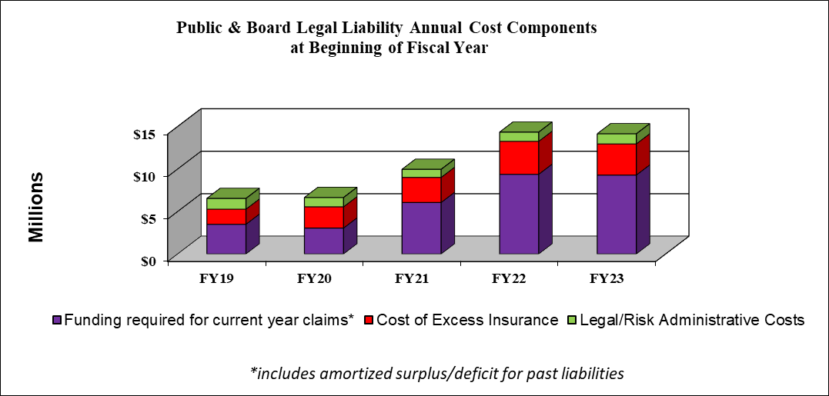

# WORKERS’ COMPENSATION

Workers’ Compensation and Employers’ Liability insurance is designed to address the medical and economic aspects of employment-related injuries. Workers’ Compensation insurance is not based on the legal concept of negligence but pays without regard to who is at fault if the injury or occupational illness arises out of and in the course and scope of employment. Workers’ Compensation insurance includes four types of benefits – disability (loss of income), medical, rehabilitation, and survivor (death).

The system has been self-insured for its workers’ compensation liabilities since 1918 and has self- administered its claims since that time as well. The Workers’ Compensation exposure is funded through three mechanisms - system internal allocation, payroll assessments, and if needed, “recovery” accounts. Except for a single year in the 1970’s, the system has not purchased commercial excess coverage for its workers’ compensation self-insurance program. In FY20, Risk Management investigated the possibility of purchasing commercial excess insurance as well as third-party claims administration. However, neither option proved cost- effective.

An annual internal allocation provides funding for claims of injured employees whose wage source is state funds. Payroll assessments provide the funding for claim payments for injured employees whose wage sources are “local” or “grant/gift” accounts. Separate claim payment accounts are maintained for state, auxiliary, and grant/gift wage sources at each of the universities. A separate account is maintained for the UIC hospital exposure as well. In addition, “recovery funds” were established in the early 1990’s as an incentive for increased safety in the workplace. The employing department is charged 49% of the cost for wages and settlements paid by workers’ compensation funds, giving them an incentive to return employees to work as soon as possible. These charges are assessed to “state” and “auxiliary” wage sources. In addition, claim payments recovered from negligent third parties (subrogation) are deposited in the “recovery” accounts. The accumulated account balance of the recovery accounts was $27.6 million as of June 30, 2023. This balance serves as a contingency source of funds in the event of a catastrophic loss. The total of all the workers’ compensation fund balances was $48 million at year-end FY2023 compared to $45 million the year prior.

The system annually obtains an actuarial analysis of its workers’ compensation self-insurance program. The report estimates the ultimate outstanding losses and expenses (liabilities) on a discounted basis at various confidence levels. The system uses the 75th percentile confidence level to determine its outstanding liabilities. Funding for liabilities is adjusted to smooth contributions using a five-year amortization of fund surpluses or deficits. When compared to the program assets, there is a funding surplus of roughly $7.7 million representing an amortized amount of about $1.1 million. The actuarial firm also determines the amount needed to set aside for funding claims that occur during each new fiscal year. The combined total is the normal indicated funding contribution of $9.8 million. With the cost of administration added, the total FY2023 funding requirement is approximately $10.6 million. This amount represents a roughly 2% decrease from the prior year funding requirement.

## WORKERS’ COMPENSATION, continued

**Worker’s Compensation Self-Insurance Funding Projected at Beginning of FY2023**

Table representing Worker's Compensation Self-Insurance Funding Projected at Beginning of FY2023 having a decrease by 2.10% compared to FY2022

**Total Medical Expenses, Fiscal Years 2019 to 2023**

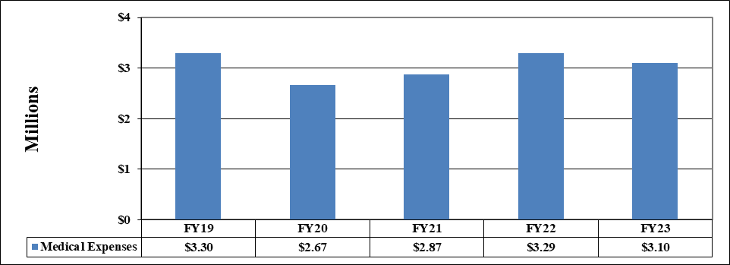

## WORKERS’ COMPENSATION, continued

**Funding and Liabilities, Fiscal Years 2019 to 2023**

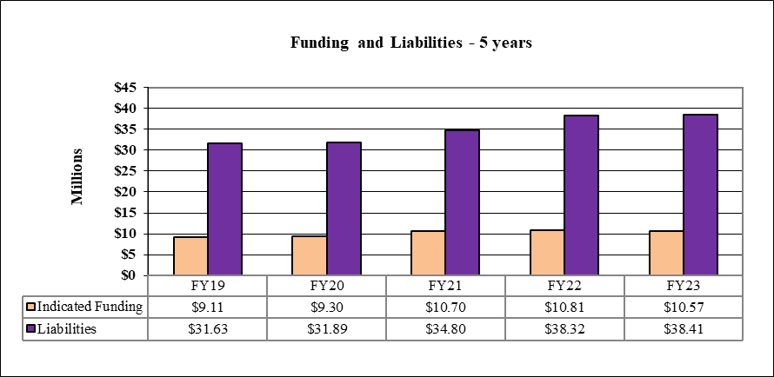

The cost of medical payments for FY23 remained stable, as did the funding and liabilities.

**Workers’ Compensation Wage Replacement and Settlements, Fiscal Years 2019 to 2023**

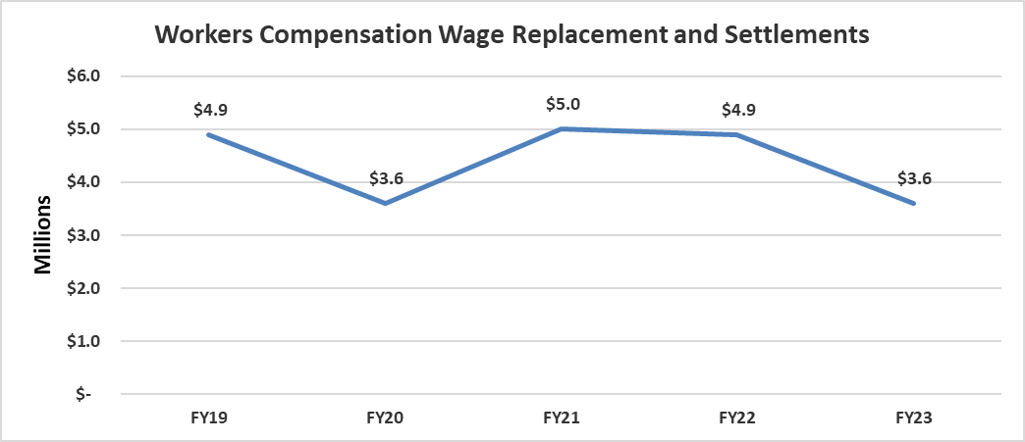

For the period ending 6/30/2023, total workers’ compensation wage and indemnity payments decreased significantly. Some of this decrease is due to having less claims settle in FY23, as well as a reduction in payments for COVID-19 related death claims. The decrease can also be attributed to the success of the return-to-work program implemented by the Office of Claims Management and Workers Compensation. The program allows the employee to return to work in a timelier manner, thus reducing the settlement as the employee returned to pre-injury status more quickly.

# PROPERTY

The University of Illinois System, along with the other members of the Illinois Public Higher Education Cooperative (IPHEC) purchasing group, procures its property insurance through the Alliant Property Insurance Program (APIP). Policy coverage terms are determined on a group basis, but each member has its own limits. For FY2023, the University of Illinois System purchased limits of $1.5 billion per occurrence.

Property insurance protects the system’s buildings and contents from direct physical loss or damage. Perils covered include fire, windstorm, hail, water and smoke damage, explosion, theft, flood, and earthquake. The policy is written on a scheduled basis to cover buildings and contents and includes business income and expense (including tuition & fees), as well as builder’s risk. The policy includes flood and earthquake coverage for all buildings at sub-limits of $100 million. All system buildings have boiler and machinery coverage. The policy deductible is $500,000 per occurrence.

Several years ago, a deductible buy-down program was established. In the event of a loss, Schedule I properties pay

$25,000, and the monies collected in the property deductible buy-down account fund the difference. Schedule II properties pay $100,000 of a loss, and the funds in the buy-down account pay the difference. In the property coverage summary below, buildings financed by bond issue; auxiliary enterprise buildings; gift-buildings; etc. are referred to as Schedule I. Academic buildings are referred to as Schedule II.

The system also insures its library collections and purchases a rare books and fine arts insurance policy to cover the valuable contents of the Krannert Art Museum (KAM), Spurlock Museum, and the system’s main library’s special collections and rare books. The cost is divided between the UIUC, the main library, Spurlock, and KAM.

**Property Coverage Policy Term: 7/1/2022 to 7/1/2023**

|  |  |  |
| --- | --- | --- |
| **Coverages** | **Values** | **Deductible** |
| **Schedule I**  (AFS, Gift, and Bond Financed Buildings/Contents, Business Income, and Boiler & Machinery) Insurance | $4,526,403,018 | $500,000 |
| **Schedule II**  (Academic Buildings only/Contents, Business Income, Library Books, and Boiler & Machinery) | $12,740,836,455 | $500,000 |

**Commercial Insurance Limits**

|  |  |
| --- | --- |
| **Coverages** | **Values** |
| Total Commercial Coverage Purchased | $1,500,000,000 |
| **Total Program Cost** | $5,564,468 |

*Cost of risk transfer to commercial carrier: $5,372,743

# FY23 EXCESS INSURANCE CARRIERS AND COSTS

### Medical Professional/Hospital Professional

For FY2023, the system purchased claims-made policies with various companies with Berkley Med as the lead carrier. We retain an $11 million per occurrence retention, with a $9 million per occurrence /$15 million inner aggregate layer. Should the system exhaust the $15 million inner aggregate, Berkley and the other companies will cover claims costs above the self-insured retention. We annually review self-insured retention levels with our consulting actuary, Milliman, to ensure the cost of risk transfer is less than the cost to assume the financial risk within the self-insurance fund.

Total limits of liability purchased are $95 million above the self-insured retention, with Berkley providing $15 million. Sompo, Medical Protective, Markel, TDC, Arch Specialty, and CapSpecialty provide the remaining $80 million of liability coverage. Defense costs are not included within the layers of commercial insurance coverage.

### Cost of risk transfer: $4,261,960

**Medical Professional/Hospital Professional “Offsite”**

For FY2023, we purchased excess coverage from Ascot and Medpro of $15 million over a retention limit of $1 million dollars for UIC College of Medicine Physicians practicing at facilities not owned or operated by the “system” or University of Illinois.

### Cost of risk transfer: $1,793,508

### Public and Board Legal Liability

For FY2023, the system’s commercial excess insurance was provided through United Educators, an insurance company known for insuring higher education institutions. The system purchases public liability insurance with a $30 million per occurrence limit and $34.5 million general aggregate, subject to a $500,000 self-insured retention. In addition, the system purchases board legal liability insurance with a $30 million occurrence/ aggregate limit, subject to a $1 million self-insured retention. Defense costs are included within each policy’s limits of liability.

### Cost of risk transfer: $3,065,487

### Cyber Liability and Breach Response

For FY2023, the system purchased cyber liability and breach response insurance through AIG in the amount of $10 million with a $500,000 self-insured retention. Defense costs erode the limit of liability.

### Cost of risk transfer: $621,992

### Property Insurance

For FY2023, the system purchased property insurance through the Alliant Property Insurance Program (APIP). Several carriers combine to provide the $100 million primary layer of insurance and the excess layers totaling $1.5 billion. The deductible is $500,000 per occurrence.

**Cost of risk transfer: $5,372,743**

# FY24 EXCESS INSURANCE CARRIERS AND COSTS

### Medical Professional/ Hospital Professional

Total limits of liability purchased are $95 million above the self-insured retention with Berkley providing $15 million. Sompo, Medical Protective, Markel, Vantage, TDC, Arch Specialty, CapSpecialty, and Ironshore provide the remaining $80 million of liability coverage. Defense costs are not included within the layers of commercial insurance coverage.

### Cost of risk transfer: $3,718,896

**Medical Professional/Hospital Professional “Offsite”**

For FY2024, we purchased excess coverage from Ascot and Medpro of $15 million over a retention limit of $1 million dollars for UIC College of Medicine Physicians practicing at facilities not owned or operated by the “system” or University of Illinois.

### Cost of risk transfer: $1,878,000

### Public and Board Legal Liability

For FY2024, the system’s commercial excess insurance is purchased through United Educators Insurance. Public Liability - $30,000,000. Defense costs are included within each policy’s limit of liability. Legal Liability - $30,000,000. Defense costs are included within each policy’s limit of liability.

### Cost of risk transfer: $3,167,506

### Cyber Liability and Breach Response

For FY2024, Cyber Liability and Breach Response insurance is purchased through AIG.

### Cost of risk transfer: $621,992 - Policy renews January 1, 2024, and we expect an increase of 15%.

### Property Insurance

For FY2024, the system renewed with the Alliant Property Insurance Program. FY24 saw substantial rate increases as well as the institution of high deductibles for specific perils. The total coverage purchased is $1.5 billion. The overall policy deductible is $500,000 per occurrence. However, losses due to water damage from frozen pipes are subject to a $3.5M per occurrence deductible, and water damage losses not due to freeze are $2M.

**Cost of risk transfer: $7,563,064**

# GLOSSARY OF TERMS

ADMINISTRATIVE COSTS – In this document, this refers to costs for University Risk Management and University Legal Services to administer the insurance programs.

AGGREGATE LIMIT – Indicates the amount of coverage the insured has under the policy/contract for a specific period of time, usually the policy/contract period, no matter how many separate accidents might occur.

BUFFER/INNER AGGREGATE – Annual per occurrence/aggregate amount to be paid when claims exceed the current self-insured retention. Once the buffer/inner aggregate has been exhausted the excess carrier policies attach above the self-insured retention.

CLAIMS MADE POLICY – Refers to a policy that covers claims only if they are “made” during the policy period. This coverage trigger is what causes the “tail” liability exposure for claims that have occurred but have not been reported.

DISCOUNTED LIABILITIES – Refers to the present value of further expected payout or liabilities.

EXCESS INSURANCE – Refers to a policy covering the insured against certain hazards and applying only to loss or damage in excess of a stated amount.

EXCESS INSURER’S – Refers to insurance companies who provide insurance protection over sizable retentions or deductibles. They price their insurance product under the assumption most claims will fall below their point of attachment.

EXCESS OF LOSS REINSURANCE – Triggered if the loss suffered by the insurer or self-insurer exceeds a set amount, called the retention.

EXPOSURE - Estimate of the probability of loss from some hazard, contingency, or circumstance.

HAZARD - The conditions that may create or increase the probability of a loss from a given peril.

HOLD HARMLESS AGREEMENT - A contract under which one party to the contract assumes the legal liability of the other party.

INCURRED LOSSES – Refers to the total of all losses occurring within a fixed period.

INCURRED BUT NOT REPORTED (IBNR) – refers to the technique of assigning claim values for claims which are assumed to have occurred, based on past claim history, but which have not yet been reported.

INDEMNIFY – To hold harmless against loss or damage.

INDEMNITY – In this document, the word indemnity is used interchangeably with settlement and is used to reference a claim payment the U of I makes a claimant or plaintiff.

IN FORCE – Amount of insurance coverage or the face amount of the policies that an insurer has underwritten.

INSURANCE - The contractual relationship that exists when one party, called the insurer, for a consideration, called a premium, agrees to reimburse another, called the insured, for loss on a specified type of coverage. Commercial insurance is purchased by an insured to transfer financial risk to the insurer.

LEGAL EXPENSES – In this document, legal expenses refer to fees paid to outside law firms for claims brought against the University and/or employees or agents, as defined in the University’s Self-Insurance Plan document. A legal expense also includes other expenses related to the defense of a claim, such as court reporting costs or the subpoena fees.

## GLOSSARY OF TERMS, continued

LEGAL LIABILITY - Liability imposed by law.

LIABILITY - Any legally enforceable obligation.

LIMITS OF LIABILITY –Maximum sum of money which the insurance company, or self- insurer, agrees to pay under the policy in the event of a covered loss.

LONG-TAIL LINES – Colloquialism describing an insurance coverage that has a lengthy period between the occurrence and final settlement of a claim. Types of long-tail insurance lines include medical malpractice, professional liability, and workers’ compensation.

LOSS RATIO – The ratio of incurred losses and loss adjustment expenses (LAE) to net premiums earned.

LOSS RESERVES – Liabilities established to pay anticipated claim costs and expenses associated with settling claims.

MALPRACTICE – Alleged professional misconduct or lack of skill in the performance of a professional act.

NEGLIGENCE – The failure to use the degree of care an ordinary person would use under given circumstances. Negligence may be constituted by acts of omission, commission, or both.

OCCURRENCE POLICY - Refers to a policy that covers claims that occur during the policy period.

POLICY – Also called the insurance policy or contract.

REINSURANCE – Coverage an insurance company purchases from other insurers to protect itself against excessive loss. The insurance company pays the other insurers a portion of the premiums it collects.

REPLACEMENT COST – The replacement value of damaged property is paid without deduction for depreciation.

RETENTION – Refers to the net amount of risk retained on a given risk. The term “retention” applies on high excess programs, whereas the term “deductible” is used on programs where little financial risk is assumed.

RISK – The term “risk” is used most commonly to denote the subject matter of insurance, i.e., the object of an underwriter’s attention. A home, a building, or a driver of a car may be referred to as a risk. In addition, the term “risk”, in the academic sense, may be used to refer to the uncertainty of financial loss. In this sense, risk is the uncertainty or chance of loss.

TAIL – Also known as an “Extended Reporting Policy Endorsement”. On claims-made policies, the “tail” refers to the exposure for claims that have occurred but are not known. When moving from one claims-made policy to another, one of two things needs to occur. Either the effective date of the new claims-made policy must have a retroactive date, which should coincide with the effective date of the first claims-made policy issued to the insured, or the insured needs to purchase the “tail” endorsement. Either is designed to prevent gaps in coverage based on when claims are reported.

TORT – A wrong; a private or civil wrong or injury resulting from a breach of a legal duty that exists by virtue of society’s expectations regarding interpersonal conduct, rather than by contract or other private relationship. There are many kinds of torts, each with different elements, but they can be generally classified into three groups: those involving intent, negligence, or strict liability. The essential elements of a tort are the existence of a legal duty owed by a defendant to a plaintiff; a breach of that duty; and a causal relationship between the defendant’s conduct and the resulting damage to the plaintiff.

UNDERWRITING – Refers to the function of securing and evaluating information and making decisions to accept or reject risks.

WORKING LAYER – An underwriting term referring to the dollar amount the insured retains, and where excess insurance sits above it. In excess liability policies, particularly malpractice, the excess insurer wants to have their coverage sit well in excess of where claims frequently settle.

**Office of Risk Management**

506 S. Wright Street, Suite 247

Champaign IL, 61820

217-333-3113

[UnivRiskMgmt@uillinois.edu](mailto:UnivRiskMgmt@uillinois.edu)