UNIVERSITY OF ILLINOIS
Urbana-Champaign • Chicago • Springfield

The Board of Trustees
352 Henry Administration Building, MC-350
506 South Wright Street
Urbana, IL 61801

NOTICE

October 7, 2022

On call of the chair, a meeting of the Executive Committee of the Board of Trustees of the University of Illinois will be held on Tuesday, October 11, 2022, beginning at 9:00 a.m. (A copy of the schedule/agenda is attached.)

Per Governor Pritzker’s September 16, 2022, Gubernatorial Disaster Proclamation and 5 ILCS 120/7(e), this meeting will be held via teleconference, available at: https://www.uis.edu/uislive.
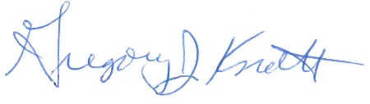
Gregory J. Knott
Secretary of the Board of Trustees

c. Members of the Board of Trustees
President Killeen
Mr. McKeever
University Officers
Members of the Press
Meeting of the Executive Committee
of the Board of Trustees
University of Illinois

October 11, 2022

VIRTUAL MEETING ROOM

The Executive Committee of the Board of Trustees Meeting will be webcast live at the following address: https://www.uis.edu/uislive

Please note that the starting times for various sessions, after the first session, are estimates. If a session ends earlier than expected, the next session scheduled may convene immediately. In addition, on some occasions the order of business may be adjusted as the meeting progresses to accommodate board members’ schedules, the length of sessions, breaks and other needs.

9:00 a.m. Meeting of the Executive Committee Convenes
- Roll Call
- Identification of University Officers and Others Present

9:05 a.m. Executive Session

11:25 a.m. Executive Session Concludes; Public Meeting of the Board Resumes

11:30 a.m. Meeting Adjourns

