UNIVERSITY OF ILLINOIS
Urbana-Champaign • Chicago • Springfield

The Board of Trustees
352 Henry Administration Building, MC-350
506 South Wright Street
Urbana, IL 61801

NOTICE

June 22, 2026

On call of the co-chairs, a meeting of the Search Committee to Assist in the Selection of a President, 2026, will be held on Wednesday, June 24, 2026, beginning at 1:30 p.m., in the Isadore and Sadie Dorin Forum, Rooms G, H, and I, 725 W. Roosevelt Road, Chicago, Illinois. (A copy of the schedule and agenda is attached.)

The meeting will also be available via videoconference from Room 3018, Campus Instructional Facility, 1405 W. Springfield Ave., Urbana, Illinois.

The committee will meet in open session to discuss the search process and in executive session to consider University employment or appointment-related matters.

The Board of Trustees meetings are open to the public, pursuant to Illinois state law and the Board’s own procedures. Attendees will not be permitted to knowingly interfere with or impede, through disruptions or other means, the Board’s performance of its institutional duties. Individuals who disrupt the meeting will be asked to leave. If the disruption continues following due notice to depart the meeting space, individuals will be removed from the premises. Individuals who disrupt the Board’s performance of its institutional duties or refuse to leave the meeting may be in violation of state laws, including but not limited to the Illinois Interference with a Public Institution of Education Act.

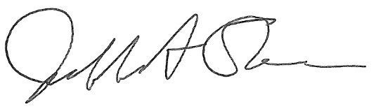
Jeffrey A. Stein
Secretary, Board of Trustees
c. Members of the Board of Trustees
President Killeen
Mr. Engle
University Officers
Members of the Press
University of Illinois

Meeting of the Search Committee to Assist in the Selection of a President, 2026
Wednesday, June 24, 2026

University of Illinois Chicago
Isadore and Sadie Dorin Forum, Rooms G, H, & I
725 West Roosevelt Road, Chicago, Illinois

VIDEOCONFERENCE LOCATION

University of Illinois Urbana-Champaign
Campus Instructional Facility, Room 3018
1405 W. Springfield Ave, Urbana, Illinois

Please note that the starting times for various sessions, after the first session, are estimates. If a session ends earlier than expected, the next session scheduled may convene immediately. In addition, on some occasions the order of business may be adjusted as the meeting progresses to accommodate committee member schedules, the length of sessions, breaks and other needs.

1:30 p.m. Convene meeting of the committee
- Roll Call

1:35 p.m. Welcome: Ramón Cepeda, Co-Chair, and Ann Yeung, Co-Chair

1:40 p.m. Public Comment

1:50 p.m. Executive Session

3:30 p.m. Adjourn

The UIC Dorin Forum does not permit graphic boards or posters inside the facility. All bags will be subject to inspection.

