UNIVERSITY OF ILLINOIS

Urbana-Champaign • Chicago • Springfield

The Board of Trustees

352 Henry Administration Building, MC-350

506 South Wright Street

Urbana, IL 61801

September 12, 2024

**NOTICE**

On call of the Chair, a meeting of the Audit, Budget, Finance, and Facilities Committee of the Board of Trustees of the University of Illinois will be held on Wednesday, September 18, 2024, beginning at 2:15 p.m., in the I Hotel and Conference Center[1], Illinois Ballroom, 1901 South First Street, Champaign, Illinois. (A copy of the schedule/agenda is attached.)

The meeting will also be webcast live at the following address:

https://www.uis.edu/uislive.

The Board of Trustees meetings are open to the public, pursuant to Illinois state law and the Board’s own procedures. Attendees will not be permitted to knowingly interfere with or impede, through disruptions or other means, the Board’s performance of its institutional duties. Individuals who disrupt the meeting will be asked to leave. If the disruption continues following due notice to depart the meeting space, individuals will be removed from the premises. Individuals who disrupt the Board’s performance of its institutional duties or refuse to leave the meeting may be in violation of state laws, including but not limited to the Illinois Interference with a Public Institution of Education Act.

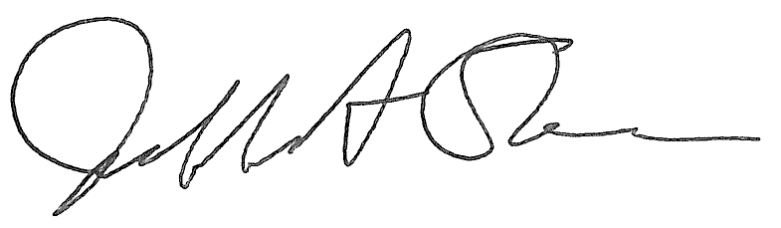

Jeffrey A. Stein Secretary of the Board of Trustees

c: Members of the Board of Trustees

President Killeen

Mr. McKeever

University Officers

Members of the Press

**Meeting of the Audit, Budget, Finance, and Facilities Committee**

**of the Board of Trustees of the University of Illinois**

University of Illinois Urbana-Champaign

I Hotel and Conference Center, Illinois Ballroom

1901 South First Street, Champaign, Illinois

The Audit, Budget, Finance, and Facilities Committee Meeting will be webcast live at the following address:

https://www.uis.edu/uislive

Please be advised that the times for various parts of the meeting are estimates and that the order of business may be adjusted as the meeting progresses.

**Wednesday, September 18, 2024**

2:15 p.m.* **Meeting of the Committee Convenes**

* Roll Call
* Opening Remarks by the Chair of the Committee
* *Action Item*- Approval of Minutes of Meeting of July 10, 2024

2:20 p.m. **Review Recommended Board Items for September 19, 2024, Board Meeting**

* + - Approve the Fiscal Year 2025 Services and Management Agreement for the University of Illinois Foundation
    - Approve Operating Budget for Fiscal Year 2025
    - Auxiliary Facilities System Refunding Revenue Bonds
    - Rename the Center for Advanced Bioenergy and Bioproducts Innovation (CABBI) Greenhouse, Urbana
    - Approve Energy Conservation Project and Professional and Construction Services Award, University Hall and Behavioral Sciences Building, Chicago
    - Purchase Recommendations

3:00 p.m. **Presentations**

* Investment Program Update
* Fourth Quarter and Annual Report for Fiscal Year Ended June 30, 2024
* *Action Item*- Approve Amendments to Internal Audit Charter for the University of Illinois System, Office of University Audits

3:20 p.m. **Old Business**

**New Business**

* + Next Meeting- November 13, 2024, 2:15 p.m., Isadore and Sadie Dorin Forum, Rooms D, E, and F, 725 West Roosevelt Road, Chicago

3:25 p.m. **Meeting of the Committee Adjourns When Business is Complete**

1. Per hotel management, the I Hotel and Conference Center does not permit signs inside the facility. All bags will be subject to inspection.