Reported to the Board of Trustees
September 19, 2024
Board Meeting
September 19, 2024

REPORT OF ACTION BY THE EXECUTIVE COMMITTEE

The following actions have been taken by the Executive Committee since the last meeting of the Board. These actions are now reported to the Board as a whole.

July 19, 2024, meeting of the Executive Committee

Approve Establishment of University-Related Organization for
Quantum Science Facilities and Delegate Authority to the President

(1) The purpose of this item is to approve establishment of a University-Related Organization to operate and manage the Quantum Science Facilities, as described below, and to make certain delegations of authority to the president.
Illinois has established itself as a leader in quantum computing and microelectronics. The State of Illinois recently approved $500.0 million to support quantum and microelectronics research and development in Illinois. Illinois is uniquely positioned over the next seven years to help the federal government achieve the goals of the federal CHIPS and Science Act. Recognizing the University of Illinois Urbana-Champaign’s breadth and depth of leadership in the quantum and microelectronics fields, the University will collaborate with partners within the state and nationally, including other Illinois universities, economic development groups, and national labs located in Illinois to lead the Quantum Science Facilities.
A planned Illinois Quantum and Microelectronics Park (the “Quantum Science Facilities”) will be considered for location in the Chicago area and will serve as a quantum computing proving ground. In support of the creation and operation of the Quantum Sciences Facilities, the chancellor of the University of Illinois Urbana-Champaign, and vice president, University of Illinois System, with the concurrence and support of the president, proposes that the Board of Trustees of the University of Illinois (UI Board) establish a University-Related Organization (URO) and that the president of the University of Illinois System be delegated the authority to take certain actions related to the formation of the URO. To do so, the University may need to engage with partners inside and outside of the University, negotiate certain agreements, and appropriately document its actions.
The URO will have a Board of Managers composed of individuals from the University of Illinois System and other partners in the Quantum Science Facilities. The proposed slate of managers will be generated in close collaboration with external partners, including the Office of the Governor, Illinois higher education peers, and members of the private and public sectors. The Board of Trustees will approve the full slate of managers at a future meeting.
The UI Board will be the sole member of the LLC and will possess and exercise such other reserved powers as provided in attendant corporate organizational documents, including, but not limited to the LLC Articles of Organization, Operating Agreement, and a Services and Management Agreement between the University and the LLC. Such reserve powers to the UI Board will include appointing voting members to the LLC Board of Managers, approval of amendments to the Articles of Organization and Operating Agreement, incurrence of long-term debt, and approval of the sale of substantially all of the assets of the LLC, among others. Consistent with other UROs, an Operating Agreement and Services and Management Agreement will be negotiated and executed between the University and the LLC.
As a URO, the LLC will comply with applicable State of Illinois Legislative Audit Commission Guidelines (LAC Guidelines), which were adopted in 1982 and amended in 1997, 2020, and 2023, and other applicable regulatory requirements.
The president of the University of Illinois System and the chancellor of the University of Illinois Urbana-Champaign and vice president, University of Illinois System, are committed to providing leadership on the Quantum Science Facilities and to cooperate with Governor J. B. Pritzker and other involved parties to demonstrate sustained commitment to the Quantum Science Facilities project. Accordingly, the chancellor recommends that the UI Board delegate authority to the president of the University of Illinois System, to take the following actions:
- Negotiate the terms of the University of Illinois’s role as the operator and manager of the Quantum Science Facilities with other partners and parties involved in the Quantum Science Facilities.
- Research and prepare a summary of financial information and projections related to the Quantum Science Facilities, using outside resources as necessary.
- Identify members of the Board of Managers to be brought before the UI Board for approval.
- Prepare and execute the necessary documentation to establish the URO to support the Quantum Science Facilities, bringing contractual agreements and other items to the UI Board for approval when required.
- Engage professionals, such as outside legal counsel and financial advisors, to advise on various aspects of the project.
- Work with internal and external stakeholders in the Quantum Science Facilities as necessary and advisable.
The Board action recommended in this item complies in all material respects with applicable State and federal laws, University of Illinois Statutes, The General Rules Concerning University Organization and Procedure, and Board of Trustees policies and directives.
The chancellor of the University of Illinois Urbana-Champaign, and vice president, University of Illinois System, recommends approval, and the president of the University of Illinois System concurs.
On motion of Ms. Holmes, seconded by Mr. Cepeda, these recommendations were approved and authority was given as recommended by the following vote: Aye, Mr. Cepeda, Mr. Edwards, Ms. Holmes; No, none.

Appointments to the Faculty, Administrative/Professional Staff,
and Intercollegiate Athletic Staff

(2) According to State statute, no student trustee may vote on those items marked with an asterisk.
In accordance with Article IX, Section 3 of the University of Illinois Statutes, the following new appointments to the faculty at the rank of assistant professor and above, and certain administrative positions, are now presented for action by the Board of Trustees.
The Board action recommended in this item complies in all material respects with applicable State and federal laws, University of Illinois Statutes, The General Rules Concerning University Organization and Procedure, and Board of Trustees policies and directives.

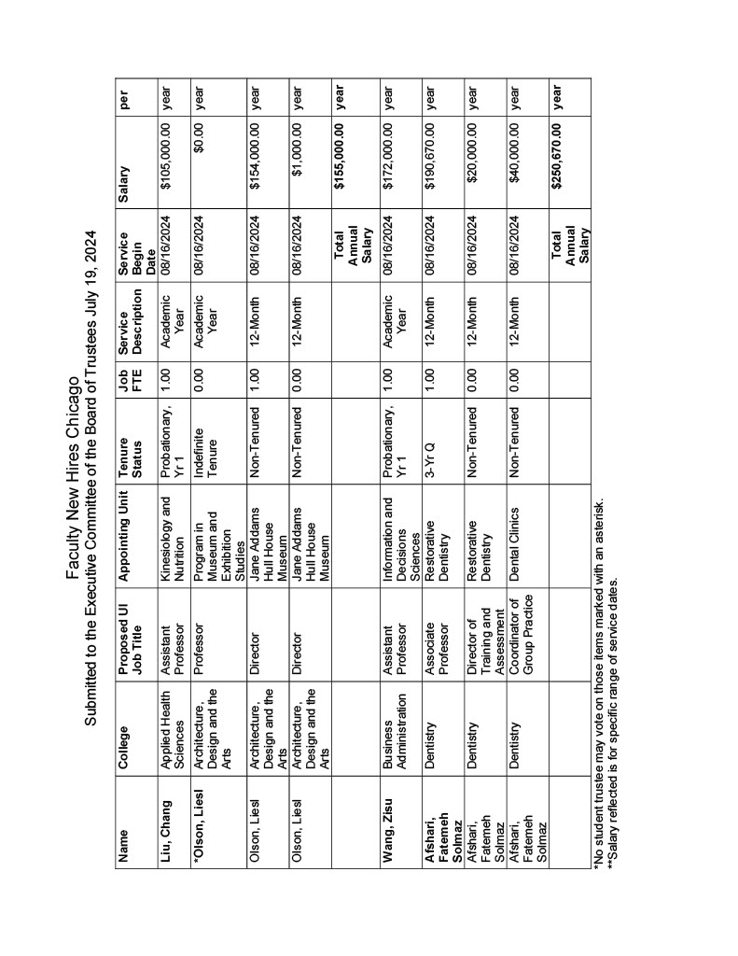
On motion of Ms. Holmes, seconded by Mr. Cepeda, these appointments were approved by the following vote: Aye, Mr. Cepeda, Mr. Edwards, Ms. Holmes; No, none.
August 15, 2024, meeting of the Executive Committee

Approve Execution of University-Related Organization Governing Documents for Illinois Quantum and Microelectronics Park, LLC

(1) On July 19, 2024, the Board of Trustees Executive Committee established a University-Related Organization (URO) to operate and manage the Quantum Science Facilities, as described below, and made certain delegations of authority to the president of the University of Illinois System related to the formation of the URO. A planned Illinois Quantum and Microelectronics Park (the “Quantum Science Facilities”) has been announced for the Chicago area and will serve as a quantum computing proving ground. The proposed name for the URO is Illinois Quantum and Microelectronics Park, LLC. Pursuant to the approval by the Board of Trustees Executive Committee on July 19, 2024, the president of the University of Illinois System has taken actions to further establish and form the URO and establish a limited liability corporation (LLC). Specifically, the president delegated to certain University units the preparation of the governing documents for the URO, including the LLC Articles of Organization, the Operating Agreement, and the Services and Management Agreement between the University and the LLC.
Therefore, the chancellor, University of Illinois Urbana-Champaign, and vice president, University of Illinois System, recommends delegation of authority to the president to review, approve, and execute governing documents to facilitate formation of the URO.
The LLC Articles of Organization, the Operating Agreement, and the Services and Management Agreement establish the URO as a legal entity and describe the relationship, rights, and obligations between the URO and the University. Pursuant to the Operating Agreement, the powers reserved to the Board of Trustees as the sole member of the URO include appointing voting members to the LLC Board of Managers, approval of amendments to the Articles of Organization and Operating Agreement, incurrence of long-term debt, approval of the sale of substantially all of the assets of the LLC, and other significant contractual agreements, among others. The Services and Management Agreement defines the obligations of the URO to manage and operate the Quantum Science Facilities in exchange for certain University services and resources.
These documents comply with applicable State of Illinois Legislative Audit Commission Guidelines (LAC Guidelines), which were adopted in 1982 and amended in 1997, 2020, and 2023, and other applicable regulatory requirements. The Operating Agreement and Services and Management Agreement are substantially completed, and drafts of these documents will be reviewed by the president, University Counsel, and other relevant University personnel prior to approval and execution. The Board of Trustees, through the powers granted to its Executive Committee, now delegates authority to approve and execute the Operating Agreement and Services and Management Agreement to the president and appropriate University officers.
The Board action recommended in this item complies in all material respects with applicable State and federal laws, University of Illinois Statutes, The General Rules Concerning University Organization and Procedure, and Board of Trustees policies and directives.
The president of the University of Illinois System concurs.
On motion of Ms. Holmes, seconded by Mr. Cepeda, this recommendation was approved and authority was given as recommended by the following vote: Aye, Mr. Cepeda, Mr. Edwards, Ms. Holmes; No, none.

Appoint Board of Managers for Illinois Quantum and Microelectronics Park, LLC

(2) On July 19, 2024, the Board of Trustees Executive Committee established a University-Related Organization (URO) to operate and manage the Quantum Science Facilities, as described below, and made certain delegations of authority to the president of the University of Illinois System related to the formation of the URO. A planned Illinois Quantum and Microelectronics Park (the “Quantum Science Facilities”) has been announced for the Chicago area and will serve as a quantum computing proving ground. The proposed name for the URO is Illinois Quantum and Microelectronics Park, LLC. Pursuant to approval of the Board of Trustees Executive Committee on July 19, 2024, the president of the University of Illinois System has taken actions to further establish and form the URO and establish a limited liability corporation (LLC).
The URO’s operations will be overseen by a Board of Managers composed of 14 individuals from the University of Illinois System and other partners in the Quantum Science Facilities. The University of Illinois System facilitated discussions about the composition of the Board of Managers with its external partners in the Quantum Science Facilities, including the Office of the Governor, Illinois higher education peers, and members of the private and public sectors, to ensure shared involvement in the URO. The proposed slate of 14 managers reflects the collaborative outcome of those discussions and includes representation from many of the partners in the Quantum Science Facilities.
Therefore, the chancellor, University of Illinois Urbana-Champaign, and vice president, University of Illinois System, recommends appointment of members of the URO Board of Managers, as follows:
Five voting managers as recommended by the Governor of the State of Illinois:
  - John Atkinson, managing director/chair at Marsh Chicago and chair, Intersect Illinois,
  - Brad Henderson, chief executive officer of P33 and board member, Intersect Illinois,
  - Casimir Peters, chief of business attraction and development, Illinois Department of Commerce and Economic Opportunity
  - Becky Locker, chief of staff, Illinois Department of Commerce and Economic Opportunity,
  - A designee from the private sector will be recommended by the Governor of the State of Illinois and appointed at future meeting of the Board of Trustees.
Three voting managers as recommended by the University of Illinois System:
  - Trustee Wilbur C. Milhouse III, chairman/CEO of Milhouse Engineering and Construction, Board of Trustees representative,
  - Rashid Bashir, dean of The Grainger College of Engineering, representative of the University of Illinois Urbana-Champaign and designated by its chancellor,
  - Susan Martinis, vice chancellor for research and innovation at the University of Illinois Urbana-Champaign, who will serve as the principal officer,
Three voting managers as recommended by the University of Chicago and its associated National Laboratories:
  - Nadya Mason, dean of the Pritzker School of Molecular Engineering, representative of the University of Chicago and recommended by its president,
  - Paul Kearns, director of Argonne National Laboratory, representative of Argonne National Laboratory and recommended by its director, with concurrence from the president of the University of Chicago,
  - Lia Merminga, director of Fermi National Accelerator Laboratory, representative of Fermi National Accelerator Laboratory and recommended by its director, with concurrence from the president of the University of Chicago
Three additional voting managers:
  - Eric Perreault, vice president for research at Northwestern University, representative from Northwestern University and recommended by its president,
  - Sonja Feist-Price, provost at Chicago State University, representative from a Minority-Serving Institution, recommended by its president or chancellor
  - Stacia Edwards, deputy provost at City Colleges of Chicago, representative from a community college, recommended by its president or chancellor
The Board action recommended in this item complies in all material respects with applicable State and federal laws, University of Illinois Statutes, The General Rules Concerning University Organization and Procedure, and Board of Trustees policies and directives.
The president of the University of Illinois System concurs.
On motion of Ms. Holmes, seconded by Mr. Cepeda, this recommendation was approved by the following vote: Aye, Mr. Cepeda, Mr. Edwards, Ms. Holmes; No, none.

